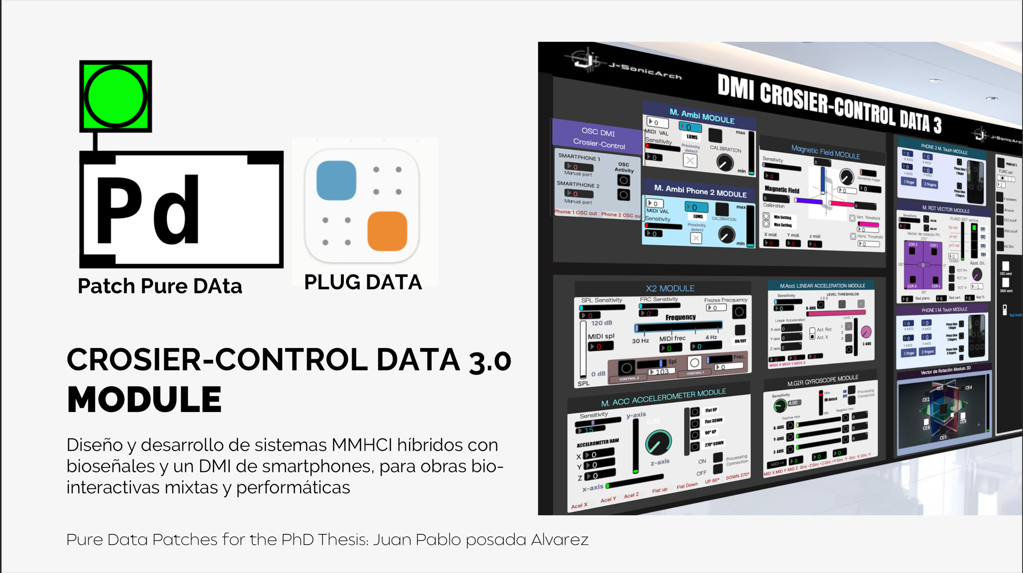



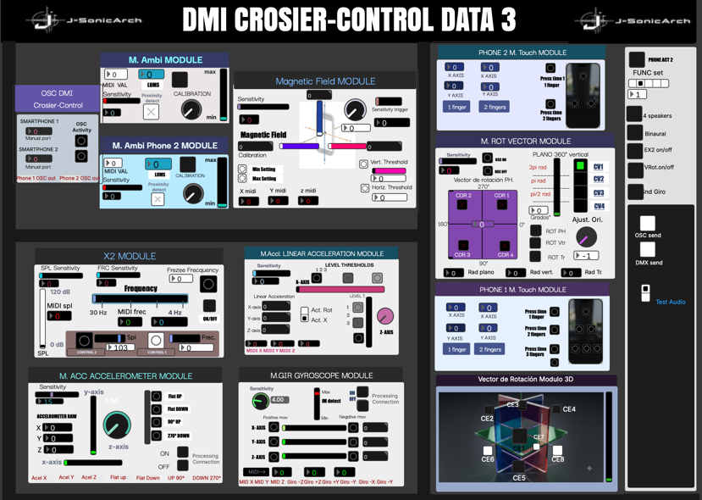
T. Touch screen module
OSC module General controls
Light/Proximity module Magnetic field Module

ModuleEx2 Rotation Vector Module
Linear aceleration

Acceleration module 3D vector rotation Modul
Giroscope Module

Fig 1 Crosier Control-Data Pd interface v3 interface

This proposal explicitly contemplates the possibility for future users to explore new combinations of IMs and modules, thus developing programming alternatives with expanded or different functionalities to those proposed here. Additionally, in this new version 3.0 module, the 3D rotation vector and the magnetic sensor module have been added. As previously explained, this version runs directly in PlugData, and the libraries must be downloaded as indicated in the repositoryFigure 1 shows the graphical interface of the Crosier-Control Data module, whose operation and control parameters are detailed below.

OSC Section:
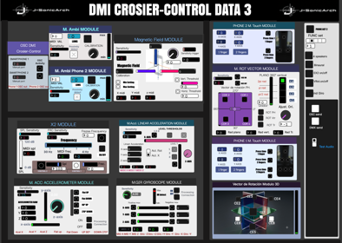

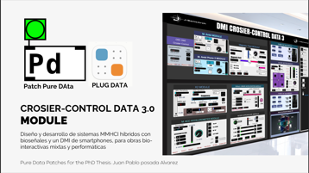
1
3
2

  - Phone Port: This selector allows you to choose 4 fixed ports for connection by OSC, 8200, 8300, 8400 and 8500.
  - Manual Port: Allows you to manually adjust the port number. This option is useful when fixed ports are busy.
  - Act LED: This display allows you to see if there is CSO activity

Control Panel Section:
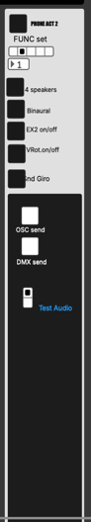
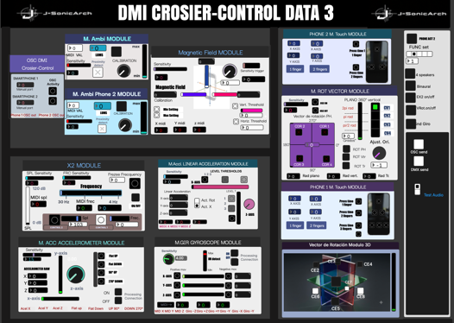
4
5
6
7
8
9 10 10 10

11
12

  - Phone 2 Act: This control activates and deactivates the functionalities of the Crosier Smartphone 2 control.
  - Func: This control activates the specific functions of PMson and routing of the modules.
  - 4 Speakers: This control activates the Quadraphonic sound functions, by default it is set to stereo.
  - Binaural: Activates the functions for Binaural spatialization. In order for sound spatiality to be appreciated, it must be listened to with headphones.
  - Ex2 on/off: This option disabled or enabled the functions of the Ex2 module. This option is implemented to avoid audio and feedback failures with the mic taking signals with high dB.
  - Vect. Rot. On/Off: This control disables interaction with the rotation vector when you want to use combined stereo and quadraphony systems or do not want to specialize the sound.
  - OSC send: This option enables or disables the sending of data to computer 2, if required.
  - DMX send: Enables and disables the sending of data for DMX interaction.
  - Test: This option activates a test audio to verify the MIDI connection with Ableton Live or the software to which it is mapped.

This manual and the accompanying documentation for Crosier Control are provided by Juan Pablo Posada Álvarez.
This repository and all associated documentation are licensed under the Creative Commons Attribution-NonCommercial-ShareAlike 4.0 International (CC BY-NC-SA 4.0) license.
License Summary:
- ✔ Free to share and adapt: You are free to copy and redistribute the material in any medium or format.
- ✔ Attribution to Juan Posada required: You must give appropriate credit, provide a link to the license, and indicate if changes were made.
- ✔ No commercial use: You may not use this material for commercial purposes.
- ✔ Share-alike for derivatives: If you remix, transform, or build upon the material, you must distribute your contributions under the same license as the original.
For further information, please visit the official project repository.



